1->userfeed- table which contains previous month user feedback and predicted value.

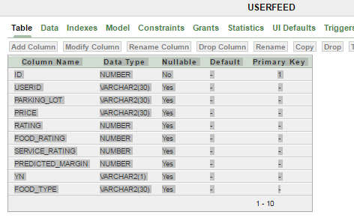

2->usefeed1- table contains user feedback for current/running month with same parameters as userfeed table.

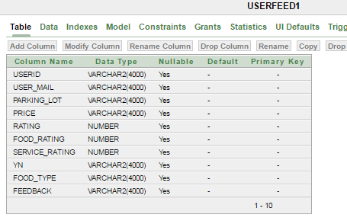

3->reguser- table contains the user which are the members of the particular organization.

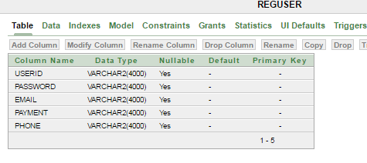

4->oldhappyuser- table contains path for the coupons for the old users who are predicted to be 'y'.

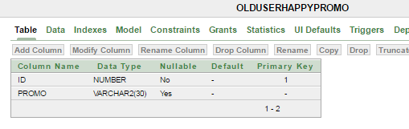

5->oldsaduser- table contains path for the coupons for the old users who are predicted to be 'n'.

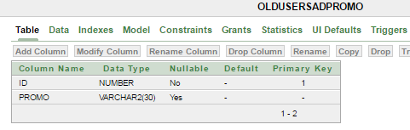

6->newuserpromo- table contains path for the coupons for the new user who will be the newest member of the organization.

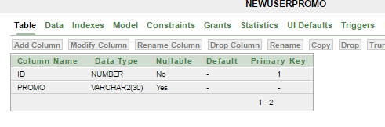

7->offer_code- table which contains offer with the unique code values to cross check the offer available.

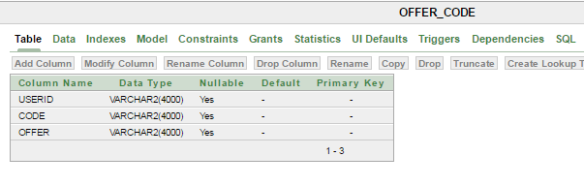

8->guestfeed- tables containing feedbacks provided by the guest customers who are not yet a member of the organization.

